**Temporal effectiveness of biodiversity surrogates in**

**coral reefs in the British Virgin Islands**

Nicole B. Keefner

Biological and Environmental Sciences

Temporal effectiveness of biodiversity surrogates in coral reefs in the British Virgin Islands

Nicole B. Keefner1

1Department of Natural Resources Science, University of Rhode Island, Kingston, RI 02881, USA.

# Abstract

Biodiversity is declining around the world, necessitating rapid identification of species distribution contractions and population declines to identify conservation priorities. Surrogates are increasingly being used to meet this challenge. A good surrogate is expected to be easier to monitor than the target component of biodiversity and meets the assumption that the target-surrogate relationship is constant over space and time. Our objective was to evaluate the spatio-temporal stability of surrogates in coral reef systems around using data from an ongoing 26-year monitoring program in the British Virgin Islands that has quantified the abundance of fish, coral, and sponge species at 8 sites. Of these taxa, corals are the most widely monitored and measures of coral cover are often assumed to be good surrogates for diversity of reef-associated taxa. We thus hypothesize that coral cover and rugosity will be good surrogates for fish, coral, and sponge species richness. We also investigated how the inclusion of recognizable taxonomic units (RTU’s) compares to species-level studies. We sought correlated relationships between the proposed surrogates and fish, coral, and sponge species richness. Our results provide insight on the use of surrogates in a coral reef ecosystem and on the inclusion of RTU’s in biodiversity studies. The identification of surrogates that maintain stable relationships with target components of biodiversity over time can inform decisions regarding existing data from monitoring studies and the allocation of limited resources for collection of future data.

# Introduction

Biodiversity changes and declines associated with increasing levels of anthropogenic stress disrupt community dynamics and are of great concern because biodiversity contributes to ecosystem function (Emmett Duffy, 2009; Staudinger et al., 2013; Stork, 2010). There are many aspects of biodiversity: landscape, ecosystem, taxonomic, and genetic diversity (Duelli & Obrist, 2003; Noss, 1990). Taxonomic diversity, particularly the diversity of species, is fundamental to understanding evolutionary patterns of distributions, interspecific interactions, and environmental conditions.Species diversity is, consequently, the most commonly measured component of biodiversity in ecological and conservation-related field studies. Species diversity is usually estimated in the field using measures such as species richness where richness is the count of species in a given area (Hamilton, 2005).

Unfortunately, a complete inventory of species present is unattainable in many ecosystems and, for taxonomic groups that can be inventoried in principle, monitoring strategies that could detect all species in a given habitat are often prohibitively expensive and time-consuming (Kati et al., 2004). In practice, surrogates are often used as simple indicators that provide an estimate of a target component of biodiversity (Magierowski & Johnson, 2006). Surrogates may be functional (e.g., structural complexity), taxonomic (e.g., species diversity), or landscape features (e.g., percent canopy cover; Paillet et al., 2018; Wessels, Freitag, & Van Jaarsveld, 1999). An effective surrogate takes less time, money, and experience to measure than the target and maintains a consistently strong correlation with the target over time and space (Magierowski & Johnson, 2006).

Ecological dynamics commonly change across spatial scales (Wiens, 1989), thus it is not surprising that most surrogate studies to date have investigated the effectiveness of surrogates across spatial scales (Kati et al., 2004). The prevalence of studies considering surrogates across spatial scales may also be due to the widespread use of surrogates to identify priority conservation areas; this task requires an understanding of how the size and dispersion of the areas being conserved will affect the dynamics between the surrogate and target (Margules, Pressey, & Williams, 2002; Padoa-Schioppa, Baietto, Massa, & Bottoni, 2006; Sarkar & Margules, 2002; T. Ward, Vanderklift, Nicholls, & Kenchington, 1999). However, few studies have explicitly investigated surrogate effectiveness across temporal scales, and those that have are typically quite short (e.g., 13 months and 1 year; Magierowski & Johnson, 2006; Rubal, Veiga, Vieira, & Sousa-Pinto, 2011). An effective surrogate must maintain a stable relationship with the target over time because environmental conditions vary and a species’ ability to respond to this variation across time changes. One of the few longer studies of ten years, which also included different geographic regions, concluded that percent canopy cover was a poor surrogate for bird richness (Pierson, Mortelliti, Barton, Lane, & Lindenmayer, 2016). Another ten year study identified a group of 35 surrogates that successfully predicted changes in the target assemblage of 98 benthic macroinvertebrate species in a temperate brackish system (Bevilacqua et al., 2018). The need for more studies that investigate the effectiveness of surrogates over time is evident.

Another widespread feature of surrogates for species diversity is a reduction of taxonomic resolution (Fontaine, Devillers, Peres-Neto, & Johnson, 2015; Musco, Mikac, Tataranni, Giangrande, & Terlizzi, 2011; Olsgard & Somerfield, 2000). Monitoring at the species level to estimate biodiversity often requires substantial taxonomic expertise (Hirst, 2008; Sebek et al., 2012). Moreover, some species that can be recognized in the lab using morphological features or genetic markers cannot be distinguished in the field during the monitoring surveys often used by specialists to estimate species richness. When individuals are not phenotypically distinguishable between taxonomic groups, studies sometimes use recognizable taxonomic units (RTU’s) that are defined by readily identifiable characteristics in the field (Derraik et al., 2002).

Coral reefs are biodiversity hotspots that are globally threatened due to environmental and anthropogenic factors, including ocean acidification, persistent high temperatures, and overfishing (T P Hughes, 1994; Terry P. Hughes et al., 2017). As such, many reefs are monitored across both spatial and temporal scales. The most commonly measured features of coral reefs are hard coral cover and structural complexity (rugosity). In fact, the temporal decline of these reef features is widely documented because they are so frequently measured (Alvarez-Filip, Carricart-Ganivet, Horta-Puga, & Iglesias-Prieto, 2013; Habibi, Setiasih, & Sartin, 2007; Stokes, Leichter, & Genovese, 2010). These measures make for good surrogates, as they are simple and affordable to measure, yet how effective they are over long temporal scales remains unknown.

Here, I evaluate the effectiveness of hard coral cover and rugosity as surrogates for species richness of major taxonomic groups on coral reefs over time and space. Percent sponge cover is also included as a candidate surrogate because sponges also play a dominant role in the benthic composition of the reef and contribute to the reef’s three-dimensional structure. Specifically, I use percent hard coral cover, percent sponge cover, and rugosity as landscape feature surrogates to predict species richness of corals, fishes, sponges, and combined richness (as the sum of richness across these three groups) using 27 years of monitoring data from eight sites around Guana Island in the British Virgin Islands (Forrester et al., 2015). Reef fishes, hard corals (Scleractinia), and sponges are dominant coral reef organisms that establish and maintain biodiversity by filling multiple functional roles in coral reef systems (Angelini, Altieri, Silliman, & Bertness, 2018). I hypothesize that coral cover will be an effective surrogate for coral species richness because declines in coral cover have been associated with declines in coral diversity (Walton, Hayes, & Gilliam, 2018). Similarly, I hypothesize that coral cover will be an effective surrogate for predicting sponge species richness because declines in coral cover have been associated with increases in sponge cover (Ruzicka et al., 2013); this inverse relationship is most likely due to competitive interactions between sponges and corals. Coral cover is often positively associated with fish species richness (Jones, McCormick, Srinivasan, & Eagle, 2004; Pratchett, Hoey, Wilson, Messmer, & Graham, 2011), most likely because corals provide fish with food (directly in the case of corallivores and indirectly by providing habitat for prey) and protection from predators. Therefore, I hypothesize that coral cover will be an effective surrogate for fish species richness. I hypothesize that rugosity will be an effective surrogate for fish species richness because greater rugosity should provide a wider variety of structures that may be utilized by a greater diversity of fish species (Darling et al., 2017; Graham et al., 2006; Gratwicke & Speight, 2005; Newman et al., 2015) and fish may respond primarily to the structure of the reef rather than its biological features (Wilson et al., 2009; Wilson, Graham, Pratchett, Jones, & Polunin, 2006). Finally, I hypothesize that rugosity will be an effective surrogate for coral species richness because a greater number of coral species should increase the number of coral morphological types and increase rugosity (Alvarez-Filip, Dulvy, Côteé, Watkinson, & Gill, 2011; Newman et al., 2015).

# Methods

## Field study design

There were eight study sites around Guana Island in the British Virgin Islands (Fig. 1). All sites were similar in covering 0.6-1.0 hectares of fringing reef adjacent to the island at a depth of 10 m. Sites varied in exposure to prevailing weather; sites on the windward north side of the island are more exposed than those on the southern leeward side. Each site was surveyed annually from 1992-2018, except that sponges were not counted in 1992, 1996-1999, 2004, 1993 at Crab Cove, 2014 at Pelican Ghut, or in 2017 at Bigelow Beach and Pelican Ghut. All surveys were conducted between June and August. Each year, fish densities, coral cover, and sponge abundances were measured using 3-12 transects (mean = 4.3) per site. Transects were 20-30.4 m long (mean = 29.95), and placed at selected locations within each site using a haphazard sampling approach.

## Survey methods

For each transect at each site, corals, sponges, and fishes were sampled once per year using well-established methods (Fig. 2). Fishes were counted within a belt transect 30 m long x 1.5 m wide, and a T-shaped bar was used to determine the transect width as the diver swam along the transect line. Fish counts were restricted to species that are amenable to visual survey, that is, day-active species that are relatively site-attached and reliably visible to divers. Nocturnal species, highly mobile groups such as mackerels (Scombridae) and jacks (Carangidae) that are transient visitors to the sites, and small cryptic groups like gobies (Gobiidae) and blennies (Blennioidei) that often hide in crevices were not surveyed. Newly recruited juvenile fishes (< 1 month on the reef) were also excluded because their abundance is strongly affected by lunar cycles, which complicates the detection of long-term trends. Because fish were the only mobile organisms of the three taxonomic groups included in this study, the fish survey was conducted first for each transect in order to reduce the bias caused by “spooking” the fish (Emslie, Cheal, MacNeil, Miller, & Sweatman, 2018). We used the linear point-intercept method to record the substrate, sponge, or coral (identified to the finest taxonomic resolution) every 0.25 m along the 30-m transect. These point observations were later converted to surface area estimates of coral percent cover and sponge percent cover (Ohlhorst, Liddell, Taylor, & Taylor, 1988). Sponges were surveyed using the line intercept method in which any sponge that intercepted the transect was recorded and identified to the finest taxonomic resolution.

Differences between observers can influence coral reef survey data, but are unlikely to influence the outcome of this study. Fish and sponge data were collected by a single respective expert observer. Coral data were collected by three observers, but new observers’ species identifications and counts were intercalibrated with those of another observer during a training period of at least 15 dives before their data were incorporated into the study.

Rugosity was measured as a proxy for three-dimensional structural complexity using the consecutive height difference method, where a diver records the difference between the top of a meter stick and the top of the reef at 50 cm intervals along each transect and uses these points to calculate a rugosity index.

*Recognizable taxonomic units*

## Fish, corals and sponges were identified to the most specific taxonomic group possible in the field. All fish were identified to species, while corals and sponges were identified as multi-species RTU’s (D. Ward & Stanley, 2004) rather than species for the following reasons: (1) taxonomists reassigned taxa thought to be different species to the same species after the study began, (2) taxonomists divided a single species into multiple species after the study began, and (3) several species are visually indistinguishable in the field. In all cases, the lowest resolution RTU was used. For example, in 1994 the coral Montastraea annularis was recognized to be three separate species (M. annularis, M. faveolata, and M. franksi) (Weil & Knowlton, 1989). Although the species can now be distinguished visually, and were counted separately after 1994, the aggregate was used because the study began in 1992 before the distinction was discovered. There were a total of 119 species of fishes, 27 recognizable taxonomic units (RTU’s) of hard corals, and 58 RTU’s of sponges (Forrester et al., 2015). We will assume the species within an RTU have the same detectability, abundance, and distribution. An RTU may include one species that may be more common than the other included in the RTU, but we assume not.

## Data Cleaning

## We used site as the sampling unit because the richness of these taxonomic groups is more relevant at the site level than at the transect level from both ecological and management perspectives. Because there were 3-22 transects in a given year at a given site, 3 transects were randomly selected for each year for each site and site-level estimates of surrogates (coral cover, sponge cover, and rugosity) were calculated by averaging these values across the 3 randomly selected transects using Program R. For the same 3 transects for each year for each site, site-level estimates of targets (coral richness, sponge richness, fish richness, and combined richness) were calculated by adding the unique number of species per transect using the following formula.

n = number of transects counted at site j in year k (n = 3)

yik = number of species counted in transect i and not counted in transects ≠ i in year k

Yjk = number of species counted at site j in year k

## Combined richness was only calculated for sites and years for which richness of all three taxonomic groups was available.

## Modeling

Based on first principles, we used the negative binomial distribution to model richness because it is a count variable.

To determine which of the candidate surrogates is best at predicting each of the targets, we used simple models with only the candidate surrogates as predictors and compared these using AIC. The top candidate surrogate identified for each target from this comparison was used for the following models. See appendices 1-4 for AIC tables from the full exploratory analysis with all models for all candidate surrogates.

To determine if relationships between targets and the top candidate surrogates remain consistent over space and time, we added additional terms to the models to account for temporal variation and variation across sites. Site is a categorical predictor of the 8 locations around Guana Island and year is a temporal trend across all sites within similar areas over the 27 years. We constrained model complexity to single pairwise comparisons because, if more complex models were supported, the relationship between the candidate surrogate and the target would not be valuable for monitoring purposes. In other words, the ecological interpretation of these more complex models would be complicated enough that there would be no clear relationship between the candidate surrogate and the target. None of the candidate surrogates seems to be related to sponge richness (Fig. 3), so we also included models without candidate surrogates to evaluate how much the candidate surrogates were contributing to the models described above. For additional support and consistency, we compared models that included terms for candidate surrogates and models without candidate surrogates for the other 3 targets as well. Models for each of the dependent variables were compared using AIC and pseudo r-squared values.

# Literature Cited

R Core Team (2017). R: A language and environment for statistical computing.

R Foundation for Statistical Computing, Vienna, Austria. URL https://www.R-project.org/.

Alvarez-Filip, L., Carricart-Ganivet, J. P., Horta-Puga, G., & Iglesias-Prieto, R. (2013). Shifts in coral-assemblage composition do not ensure persistence of reef functionality. *Scientific Reports*, *3*, 1–5. https://doi.org/10.1038/srep03486

Alvarez-Filip, L., Dulvy, N. K., Côteé, I. M., Watkinson, A. R., & Gill, J. A. (2011). Coral identity underpins architectural complexity on Caribbean reefs. *Ecological Applications*, *21*(6), 2223–2231. https://doi.org/10.1890/10-1563.1

Angelini, C., Altieri, A. H., Silliman, B. R., & Bertness, M. D. (2018). Interactions among Foundation Species and Their Consequences ­ for Community Organization , Biodiversity , and Conservation, *61*(10). https://doi.org/10.1525/bio.2011.61.10.8

Bak, R. P. M., & Engel, M. S. (1979). Distribution, abundance and survival of juvenile hermatypic corals (Scleractina) and the importance of life history strategies in the parent coral community. *Marine Biology*, *54*, 341–352.

Bell, J. J. (2008). The functional roles of marine sponges. *Estuarine, Coastal and Shelf Science*, *79*, 341–353. https://doi.org/10.1016/j.ecss.2008.05.002

Bellwood, D. R., Hughes, T. P., Folke, C., & Nyström, M. (2004). Confronting the coral reef crisis. *Nature*, *429*, 827–833. https://doi.org/https://doi.org/10.1038/nature21707

Darling, E. S., Graham, N. A. J., Januchowski-Hartley, F. A., Nash, K. L., Pratchett, M. S., & Wilson, S. K. (2017). Relationships between structural complexity, coral traits, and reef fish assemblages. *Coral Reefs*, *36*, 561–575. https://doi.org/10.1007/s00338-017-1539-z

Derraik, J. G. B., Closs, G. P., Dickinson, K. J. M., Sirvid, P., Barratt, B. I. P., & Patrick, B. H. (2002). Arthropod Morphospecies versus Taxonomic Species:a Case Study with Araneae, Coleoptera,and Lepidoptera. *Conservation Biology*, *16*(4), 1015–1023. https://doi.org/10.1046/j.1523-1739.2002.00358.x

Duelli, P., & Obrist, M. K. (2003). Biodiversity indicators: The choice of values and measures. *Agriculture, Ecosystems and Environment*, *98*(1–3), 87–98. https://doi.org/10.1016/S0167-8809(03)00072-0

Emmett Duffy, J. (2009). Why biodiversity is important to the functioning of real-world ecosystems. *Frontiers in Ecology and the Environment*, *7*(8), 437–444. https://doi.org/10.1890/070195

Emslie, M. J., Cheal, A. J., MacNeil, M. A., Miller, I. R., & Sweatman, H. P. A. (2018). Reef fish communities are spooked by scuba surveys and may take hours to recover. *PeerJ*, *6*, e4886. https://doi.org/10.7717/peerj.4886

Fontaine, A., Devillers, R., Peres-Neto, P. R., & Johnson, L. E. (2015). Delineating marine ecological units: A novel approach for deciding which taxonomic group to use and which taxonomic resolution to choose. *Diversity and Distributions*. https://doi.org/10.1111/ddi.12361

Forrester, G., Baily, P., Conetta, D., Forrester, L., Kintzing, E., & Jarecki, L. (2015). Comparing monitoring data collected by volunteers and professionals shows that citizen scientists can detect long-term change on coral reefs. *Journal for Nature Conservation*, *24*, 1–9. https://doi.org/10.1016/j.jnc.2015.01.002

Graham, N. A. J., Wilson, S. K., Jennings, S., Polunin, N. V. C., Bijoux, J. P., & Robinson, J. (2006). Dynamic fragility of oceanic coral reef ecosystems, *103*(22).

Gratwicke, B., & Speight, M. (2005). The relationship between fish species richness , abundance and habitat complexity in a range of shallow tropical marine habitats. *Journal of Fish Biology*, *66*, 650–667. https://doi.org/10.1111/j.1095-8649.2005.00629.x

Habibi, A., Setiasih, N., & Sartin, J. (2007). A decade of reef check monitoring: Indonesian coral reefs, condition and trends.

Halpern, B. S., & Floeter, S. R. (2008). Functional diversity responses to changing species richness in reef fish communities. *Marine Ecology Progress Series*. https://doi.org/10.3354/meps07553

Hamilton, A. J. (2005). Species diversity or biodiversity? *Journal of Environmental Management*. https://doi.org/10.1016/j.jenvman.2004.11.012

Hirst, A. (2008). Surrogate measures for assessing cryptic faunal biodiversity on macroalgal-dominated subtidal reefs. *Biol Cons*, *141*.

Hughes, T. P. (1994). Catastrophes, Phase Shifts, and larg-scale degradation of a Caribbean coral reef. *Science*, *265*, 1547–1551. Retrieved from http://science.sciencemag.org/content/265/5178/1547.long

Hughes, T. P., Kerry, J. T., Álvarez-Noriega, M., Álvarez-Romero, J. G., Anderson, K. D., Baird, A. H., … Wilson, S. K. (2017). Global warming and recurrent mass bleaching of corals. *Nature*, *543*(7645), 373–377. https://doi.org/10.1038/nature21707

Jones, G. P., McCormick, M. I., Srinivasan, M., & Eagle, J. V. (2004). Coral decline threatens fish biodiversity in marine reserves. *Proceedings of the National Academy of Sciences*, *101*(21), 8251–8253. https://doi.org/10.1073/pnas.0401277101

Kati, V., Devillers, P., Dufrˆene, M., Dufrˆene, D., Legakis, A., Vokou, D., & Lebrun, P. (2004). *Testing the Value of Six Taxonomic Groups as Biodiversity Indicators at a Local Scale*. *Conservation Biology* (Vol. 18).

Magierowski, R. H., & Johnson, C. R. (2006). *Robustness of surrogates of Biodiversity in Marine Benthic Communities*. *Ecological Applications* (Vol. 16).

Margules, C., Pressey, R., & Williams, P. (2002). Representing biodiversity: data and procedures for identifying priority areas for conservation. *J Biosci*, *27*.

Musco, L., Mikac, B., Tataranni, M., Giangrande, A., & Terlizzi, A. (2011). The use of coarser taxonomy in the detection of long-term changes in polychaete assemblages. *Marine Environmental Research*. https://doi.org/10.1016/j.marenvres.2010.12.004

Newman, S. P., Meesters, E. H., Dryden, C. S., Williams, S. M., Sanchez, C., Mumby, P. J., & Polunin, N. V. C. (2015). Reef flattening effects on total richness and species responses in the Caribbean. *Journal of Animal Ecology*, *84*, 1678–1689. https://doi.org/10.1111/1365-2656.12429

Noss, R. F. (1990). Indicators for monitoring biodiversity: A hierarchical approach. *Conservation Biology*, *4*(4), 355–364.

Nyström, M. (2006). Redundancy and response diversity of functional groups: Implications for the resilience of coral reefs. *AMBIO: A Journal of the Human Environment*, *35*(1), 30–35. https://doi.org/10.1579/0044-7447-35.1.30

Ohlhorst, S. L., Liddell, W. D., Taylor, R. J., & Taylor, J. M. (1988). EVALUATION OF REEF CENSUS TECHNIQUES. *Proceedings of the 6th International Coral Reef Symposium, Australia*, *2*, 319–324.

Olsgard, F., & Somerfield, P. (2000). Surrogates in marine benthic investigations: Which taxonomic unit to target? *J Aquat Ecosyst Stress Recovery*, *7*.

Padoa-Schioppa, E., Baietto, M., Massa, R., & Bottoni, L. (2006). Bird communities as bioindicators: The focal species concept in agricultural landscapes. *Ecological Indicators*. https://doi.org/10.1016/j.ecolind.2005.08.006

Paillet, Y., Archaux, F., du Puy, S., Bouget, C., Boulanger, V., Debaive, N., … Guilbert, E. (2018). The indicator side of tree microhabitats: A multi-taxon approach based on bats, birds and saproxylic beetles. *Journal of Applied Ecology*, *55*(5), 2147–2159. https://doi.org/10.1111/1365-2664.13181

Pratchett, M. S., Hoey, A. S., Wilson, S. K., Messmer, V., & Graham, N. A. J. (2011). Changes in biodiversity and functioning of reef fish assemblages following coral bleaching and coral loss. *Diversity*, *3*(3), 424–452. https://doi.org/10.3390/d3030424

Rubal, M., Veiga, P., Vieira, R., & Sousa-Pinto, I. (2011). Seasonal patterns of tidepool macroalgal assemblages in the North of Portugal. Consistence between species and functional group approaches. *Journal of Sea Research*. https://doi.org/10.1016/j.seares.2011.07.003

Ruzicka, R. R., Colella, M. A., Porter, J. W., Morrison, J. M., Kidney, J. A., Brinkhuis, V., … Colee, J. (2013). Temporal changes in benthic assemblages on Florida Keys reefs 11 years after the 1997/1998 El Niño. *Marine Ecology Progress Series*, *489*, 125–141. https://doi.org/10.3354/meps10427

Sarkar, S., & Margules, C. (2002). Operationalizing biodiversity for conservation planning. *J Biosci*, *27*.

Sebek, P., Barnouin, T., Brin, A., Brustel, H., Dufrêne, M., Gosselin, F., … Bouget, C. (2012). A test for assessment of saproxylic beetle biodiversity using subsets of “monitoring species.” *Ecological Indicators*, *20*, 304–315. https://doi.org/10.1016/j.ecolind.2012.02.033

Staudinger, M. D., Carter, S. L., Cross, M. S., Dubois, N. S., Duffy, J. E., Enquist, C., … Turner, W. (2013). Biodiversity in a changing climate : A synthesis of current and projected trends in the US in a nutshell. *Frontiers in Ecology and the Environment*, *11*(9), 465–473. https://doi.org/10.1890/120272

Stokes, M. D., Leichter, J. J., & Genovese, S. J. (2010). LONG-TERM DECLINES IN CORAL COVER AT BONAIRE, NETHERLANDS ANTILLES. *Atoll Research Bulletin*, (582), 1–21.

Stork, N. E. (2010). Re-assessing current extinction rates. *Biodiversity and Conservation*, *19*(2), 357–371. https://doi.org/10.1007/s10531-009-9761-9

Walton, C. J., Hayes, N. K., & Gilliam, D. S. (2018). Impacts of a Regional, Multi-Year, Multi-Species Coral Disease Outbreak in Southeast Florida. *Frontiers in Marine Science*, *5*(September), 1–14. https://doi.org/10.3389/fmars.2018.00323

Ward, D., & Stanley, M. (2004). The value of RTUs and parataxonomy versus taxonomic species. *New Zealand Entomologist*, *27*, 3–9. Retrieved from http://www.tandfonline.com/doi/abs/10.1080/00779962.2004.9722118

Ward, T., Vanderklift, M., Nicholls, A., & Kenchington, R. (1999). Selecting marine reserves using habitats and species assemblages as surrogates for biological diversity. *Ecol Appl*, *9*.

Weil, E., & Knowlton, N. (1989). A multi-character analysis of the Caribbean coral Montastraea annularis and its two sibling species M. faveolata and M. franksi. *Smithsonian*, *55*(September).

Wessels, K. J., Freitag, S., & Van Jaarsveld, A. S. (1999). The use of land facets as biodiversity surrogates during reserve selection at a local scale. *Biological Conservation*, *89*(1), 21–38. https://doi.org/10.1016/S0006-3207(98)00133-5

Wiens, J. (1989). Spatial Scaling in Ecology. *Functional Ecology*, *3*(4), 385–397.

Wilson, S. K., Dolman, A. M., Cheal, A. J., Emslie, M. J., Pratchett, M. S., & Sweatman, H. P. A. (2009). Maintenance of fish diversity on disturbed coral reefs. *Coral Reefs*, *28*(1), 3–14. https://doi.org/10.1007/s00338-008-0431-2

Wilson, S. K., Graham, N. A. J., Pratchett, M. S., Jones, G. P., & Polunin, N. V. C. (2006). Multiple disturbances and the global degradation of coral reefs: are reef fishes at risk or resilient? *Global Change Biology*, *12*(11), 2220–2234. https://doi.org/10.1111/j.1365-2486.2006.01252.x

Table 1. AIC table of models with coral richness as the response variable and coral cover as the candidate surrogate where cc = coral cover, yr = year, x = interaction.

|  |  |  |  |  |  |  |  |
| --- | --- | --- | --- | --- | --- | --- | --- |
| **Modnames** | **K** | **AICc** | **Delta_AICc** | **ModelLik** | **AICcWt** | **LL** | **Cum.Wt** |
| cc_yr | 4 | 1044.212 | 0.000 | 1.000 | 0.581 | -518.011 | 0.581 |
| cc_yr_yrxcc | 5 | 1045.632 | 1.419 | 0.492 | 0.286 | -517.673 | 0.866 |
| cc_yr_site | 11 | 1047.160 | 2.947 | 0.229 | 0.133 | -511.933 | 0.999 |
| cc | 3 | 1058.242 | 14.029 | 0.001 | 0.001 | -526.064 | 1.000 |
| cc_site | 10 | 1062.535 | 18.323 | 0.000 | 0.000 | -520.731 | 1.000 |
| cc_site_sitexcc | 17 | 1064.153 | 19.941 | 0.000 | 0.000 | -513.531 | 1.000 |
| site | 9 | 1083.722 | 39.510 | 0.000 | 0.000 | -532.424 | 1.000 |
| yr_site | 10 | 1085.388 | 41.176 | 0.000 | 0.000 | -532.157 | 1.000 |
| yr_site_yrxsite | 17 | 1091.270 | 47.058 | 0.000 | 0.000 | -527.090 | 1.000 |
| yr | 3 | 1165.024 | 120.812 | 0.000 | 0.000 | -579.456 | 1.000 |

Table 2. AIC table of models with sponge richness as the response variable and coral cover as the candidate surrogate where cc = coral cover, yr = year, x = interaction.

|  |  |  |  |  |  |  |  |
| --- | --- | --- | --- | --- | --- | --- | --- |
| **Modnames** | **K** | **AICc** | **Delta_AICc** | **ModelLik** | **AICcWt** | **LL** | **Cum.Wt** |
| yr_site | 10 | 909.113 | 0.000 | 1.000 | 0.515 | -443.838 | 0.515 |
| cc_yr_site | 11 | 909.336 | 0.223 | 0.894 | 0.461 | -442.800 | 0.976 |
| yr_site_yrxsite | 17 | 915.473 | 6.360 | 0.042 | 0.021 | -438.641 | 0.998 |
| site | 9 | 920.497 | 11.384 | 0.003 | 0.002 | -450.664 | 0.999 |
| cc_site | 10 | 922.256 | 13.143 | 0.001 | 0.001 | -450.409 | 1.000 |
| cc_site_sitexcc | 17 | 933.829 | 24.717 | 0.000 | 0.000 | -447.819 | 1.000 |
| cc_yr | 4 | 966.272 | 57.159 | 0.000 | 0.000 | -479.010 | 1.000 |
| cc_yr_yrxcc | 5 | 966.641 | 57.529 | 0.000 | 0.000 | -478.131 | 1.000 |
| cc | 3 | 967.524 | 58.411 | 0.000 | 0.000 | -480.687 | 1.000 |
| yr | 3 | 990.797 | 81.684 | 0.000 | 0.000 | -492.323 | 1.000 |

Table 3. AIC table of models with fish richness as the response variable and rugosity as the candidate surrogate where r = rugosity, yr = year, x = interaction.

|  |  |  |  |  |  |  |  |
| --- | --- | --- | --- | --- | --- | --- | --- |
| **Modnames** | **K** | **AICc** | **Delta_AICc** | **ModelLik** | **AICcWt** | **LL** | **Cum.Wt** |
| site | 9 | 1203.337 | 0.000 | 1.000 | 0.391 | -592.232 | 0.391 |
| r_site | 10 | 1203.822 | 0.485 | 0.785 | 0.307 | -591.374 | 0.698 |
| yr_site | 10 | 1204.682 | 1.345 | 0.510 | 0.200 | -591.804 | 0.897 |
| r_yr_site | 11 | 1206.023 | 2.686 | 0.261 | 0.102 | -591.364 | 0.999 |
| yr_site_yrxsite | 17 | 1216.549 | 13.212 | 0.001 | 0.001 | -589.729 | 1.000 |
| r_site_sitexr | 17 | 1217.027 | 13.690 | 0.001 | 0.000 | -589.968 | 1.000 |
| r_yr_yrxr | 5 | 1260.923 | 57.586 | 0.000 | 0.000 | -625.319 | 1.000 |
| r_yr | 4 | 1261.642 | 58.305 | 0.000 | 0.000 | -626.726 | 1.000 |
| r | 3 | 1266.254 | 62.917 | 0.000 | 0.000 | -630.070 | 1.000 |
| yr | 3 | 1391.343 | 188.006 | 0.000 | 0.000 | -692.615 | 1.000 |

Table 4. AIC table of models with combined richness as the response variable and rugosity as the candidate surrogate where r = rugosity, yr = year, x = interaction.

|  |  |  |  |  |  |  |  |
| --- | --- | --- | --- | --- | --- | --- | --- |
| **Modnames** | **K** | **AICc** | **Delta_AICc** | **ModelLik** | **AICcWt** | **LL** | **Cum.Wt** |
| r_yr_site | 11 | 1079.726 | 0.000 | 1.000 | 0.725 | -527.995 | 0.725 |
| yr_site | 10 | 1083.109 | 3.383 | 0.184 | 0.134 | -530.836 | 0.859 |
| yr_site_yrxsite | 17 | 1084.786 | 5.059 | 0.080 | 0.058 | -523.297 | 0.917 |
| site | 9 | 1084.834 | 5.108 | 0.078 | 0.056 | -532.833 | 0.973 |
| r_site | 10 | 1086.481 | 6.754 | 0.034 | 0.025 | -532.521 | 0.998 |
| r_yr | 4 | 1092.837 | 13.110 | 0.001 | 0.001 | -542.293 | 0.999 |
| r_site_sitexr | 17 | 1093.227 | 13.501 | 0.001 | 0.001 | -527.518 | 1.000 |
| r_yr_yrxr | 5 | 1094.828 | 15.102 | 0.001 | 0.000 | -542.224 | 1.000 |
| r | 3 | 1106.757 | 27.031 | 0.000 | 0.000 | -550.304 | 1.000 |
| yr | 3 | 1150.369 | 70.643 | 0.000 | 0.000 | -572.110 | 1.000 |



Figure 1. A map of Guana Island, British Virgin Islands, showing the eight study sites: (1) Grand Ghut, (2) Pelican Ghut, (3) Bigelow Beach, (4) Monkey Point, (5) White Bay, (6) Iguana Head, (7) Crab Cove, and (8) Long Point.

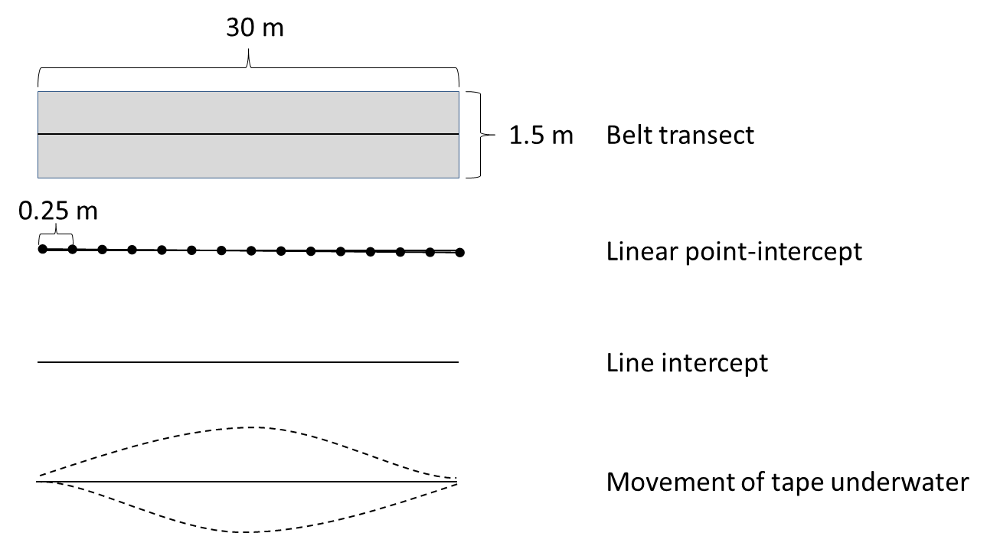

Figure 2. Preliminary depictions of the various transect methods used in this survey.

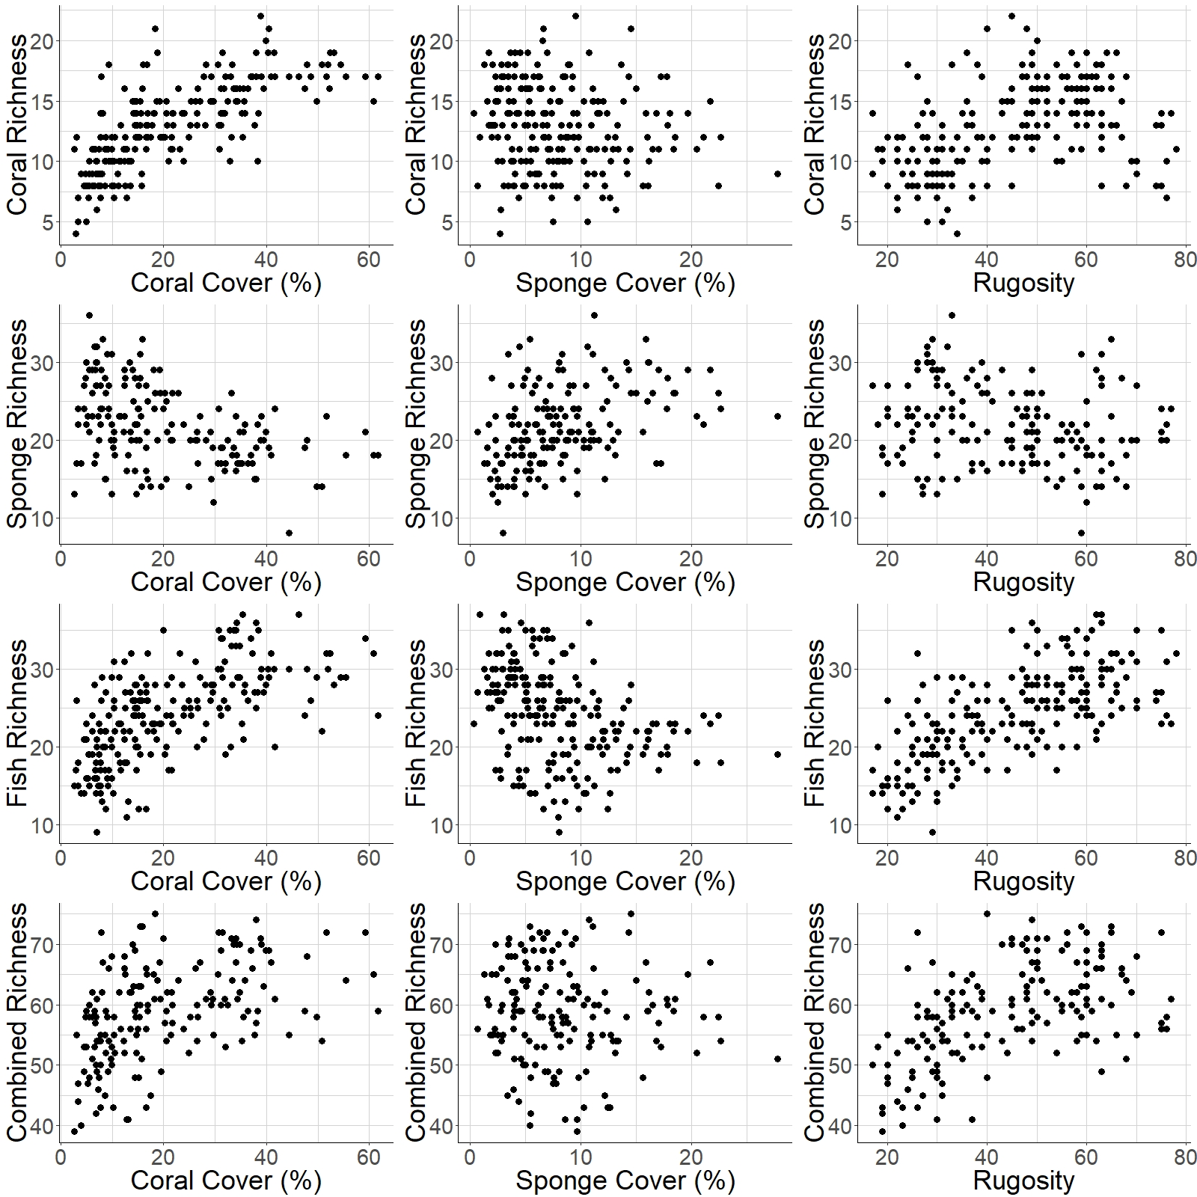

Figure 3. Basic relationships between the targets (rows) and candidate surrogates (columns). Coral cover is the best predictor of coral richness and sponge richness of these candidate surrogates. Rugosity is the best predictor of fish richness and combined richness of these candidate surrogates.

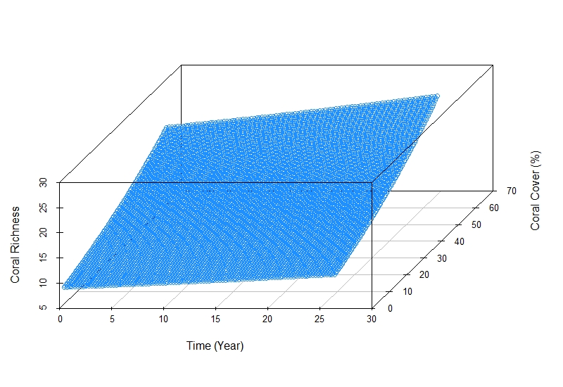

Figure 4. Relationship between coral cover and coral richness over time predicted from the model Coral Richness ~ Coral Cover + Year, where Year 0 is 1992 and Year 26 is 2018.

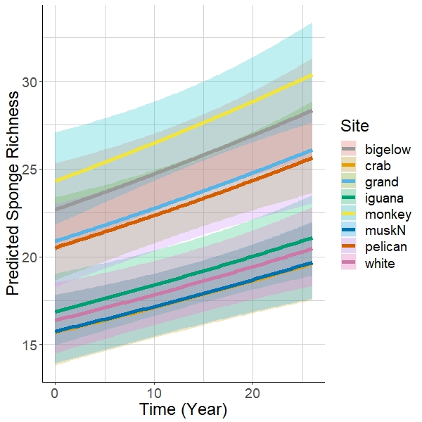

Figure 5. Relationship between time and sponge richness for the 8 sites around Guana Island predicted from the model Sponge Richness ~ Year + Site, where Year 0 is 1992 and Year 26 is 2018.

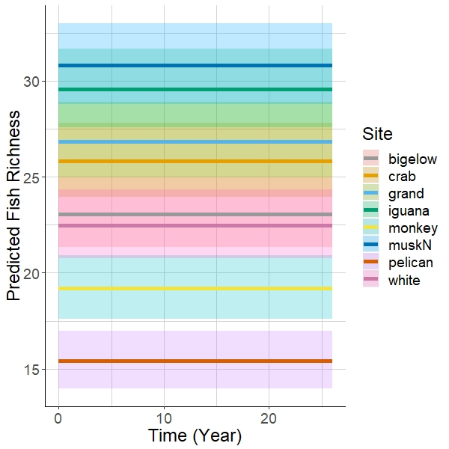

Figure 6. Relationship between time and fish richness for the 8 sites around Guana Island predicted from the model Fish Richness ~ Site, where Year 0 is 1992 and year 26 is 2018.

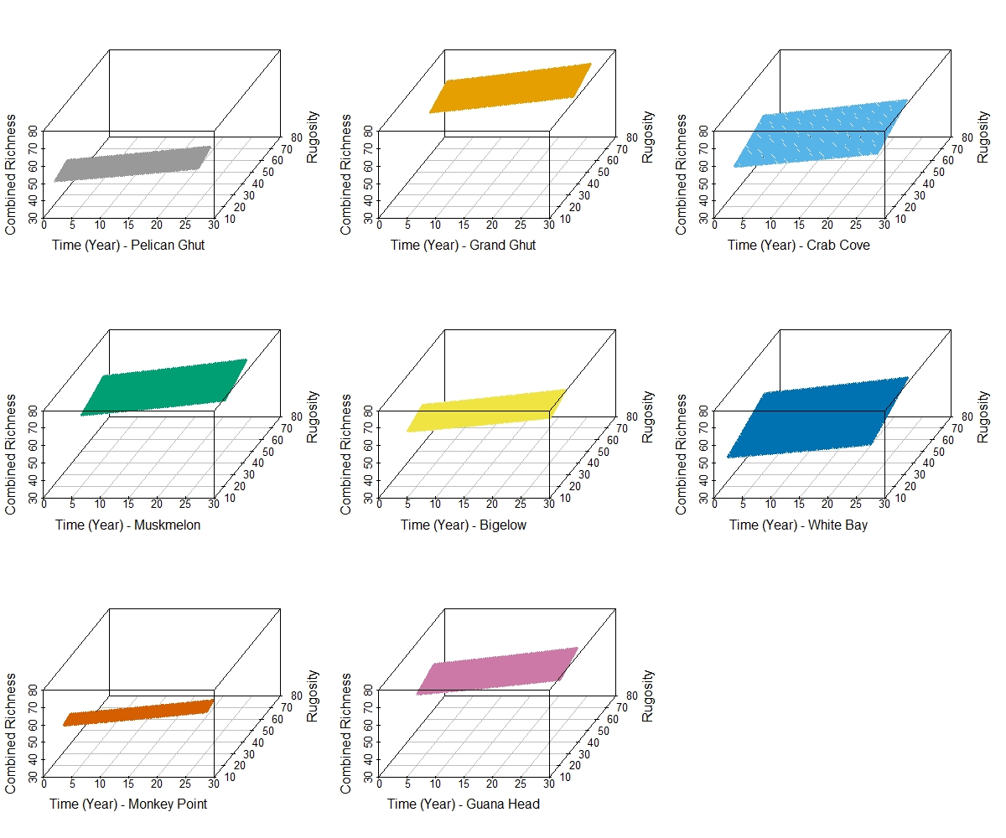

Figure 7. Relationship between rugosity and combined richness over time for each of the 8 sites around Guana Island predicted from the model Combined Richness ~ Rugosity + Year + Site, where Year 0 is 1992 and Year 26 is 2018.

Appendix 1: AIC table of models with coral richness as the response variable where cc = coral cover, sc = sponge cover, r = rugosity, yr = year, x = interaction.

|  |  |  |  |  |  |  |  |
| --- | --- | --- | --- | --- | --- | --- | --- |
| **Modnames** | **K** | **AICc** | **Delta_AICc** | **ModelLik** | **AICcWt** | **LL** | **Cum.Wt** |
| cc_yr | 4 | 1044.212 | 0.000 | 1.000 | 0.581 | -518.011 | 0.581 |
| cc_yr_yrxcc | 5 | 1045.632 | 1.419 | 0.492 | 0.286 | -517.673 | 0.866 |
| cc_yr_site | 11 | 1047.160 | 2.947 | 0.229 | 0.133 | -511.933 | 0.999 |
| cc | 3 | 1058.242 | 14.029 | 0.001 | 0.001 | -526.064 | 1.000 |
| cc_site | 10 | 1062.535 | 18.323 | 0.000 | 0.000 | -520.731 | 1.000 |
| cc_site_sitexcc | 17 | 1064.153 | 19.941 | 0.000 | 0.000 | -513.531 | 1.000 |
| sc_site | 10 | 1078.735 | 34.522 | 0.000 | 0.000 | -528.831 | 1.000 |
| sc_yr_site | 11 | 1080.904 | 36.692 | 0.000 | 0.000 | -528.805 | 1.000 |
| site | 9 | 1083.722 | 39.510 | 0.000 | 0.000 | -532.424 | 1.000 |
| r_yr_site | 11 | 1084.200 | 39.988 | 0.000 | 0.000 | -530.453 | 1.000 |
| r_site | 10 | 1084.946 | 40.734 | 0.000 | 0.000 | -531.936 | 1.000 |
| yr_site | 10 | 1085.388 | 41.176 | 0.000 | 0.000 | -532.157 | 1.000 |
| r_site_sitexr | 17 | 1090.887 | 46.674 | 0.000 | 0.000 | -526.898 | 1.000 |
| yr_site_yrxsite | 17 | 1091.270 | 47.058 | 0.000 | 0.000 | -527.090 | 1.000 |
| sc_site_sitexsc | 17 | 1092.497 | 48.285 | 0.000 | 0.000 | -527.703 | 1.000 |
| r_yr | 4 | 1127.077 | 82.864 | 0.000 | 0.000 | -559.443 | 1.000 |
| r_yr_yrxr | 5 | 1127.962 | 83.749 | 0.000 | 0.000 | -558.838 | 1.000 |
| r | 3 | 1131.209 | 86.997 | 0.000 | 0.000 | -562.548 | 1.000 |
| sc | 3 | 1161.083 | 116.871 | 0.000 | 0.000 | -577.485 | 1.000 |
| sc_yr | 4 | 1162.199 | 117.987 | 0.000 | 0.000 | -577.005 | 1.000 |
| sc_yr_yrxsc | 5 | 1163.650 | 119.437 | 0.000 | 0.000 | -576.682 | 1.000 |
| yr | 3 | 1165.024 | 120.812 | 0.000 | 0.000 | -579.456 | 1.000 |

Appendix 2: AIC table of models with sponge richness as the response variable where cc = coral cover, sc = sponge cover, r = rugosity, yr = year, x = interaction.

|  |  |  |  |  |  |  |  |
| --- | --- | --- | --- | --- | --- | --- | --- |
| **Modnames** | **K** | **AICc** | **Delta_AICc** | **ModelLik** | **AICcWt** | **LL** | **Cum.Wt** |
| r_yr_site | 11 | 908.145 | 0.000 | 1.000 | 0.415 | -442.204 | 0.415 |
| yr_site | 10 | 909.113 | 0.968 | 0.616 | 0.256 | -443.838 | 0.671 |
| cc_yr_site | 11 | 909.336 | 1.191 | 0.551 | 0.229 | -442.800 | 0.900 |
| sc_yr_site | 11 | 911.264 | 3.119 | 0.210 | 0.087 | -443.763 | 0.987 |
| yr_site_yrxsite | 17 | 915.473 | 7.328 | 0.026 | 0.011 | -438.641 | 0.998 |
| site | 9 | 920.497 | 12.352 | 0.002 | 0.001 | -450.664 | 0.999 |
| cc_site | 10 | 922.256 | 14.111 | 0.001 | 0.000 | -450.409 | 0.999 |
| r_site | 10 | 922.510 | 14.365 | 0.001 | 0.000 | -450.536 | 1.000 |
| sc_site | 10 | 922.530 | 14.385 | 0.001 | 0.000 | -450.546 | 1.000 |
| sc_site_sitexsc | 17 | 929.379 | 21.235 | 0.000 | 0.000 | -445.594 | 1.000 |
| r_site_sitexr | 17 | 931.151 | 23.006 | 0.000 | 0.000 | -446.480 | 1.000 |
| cc_site_sitexcc | 17 | 933.829 | 25.685 | 0.000 | 0.000 | -447.819 | 1.000 |
| sc_yr | 4 | 964.592 | 56.448 | 0.000 | 0.000 | -478.170 | 1.000 |
| cc_yr | 4 | 966.272 | 58.127 | 0.000 | 0.000 | -479.010 | 1.000 |
| sc_yr_yrxsc | 5 | 966.322 | 58.177 | 0.000 | 0.000 | -477.971 | 1.000 |
| cc_yr_yrxcc | 5 | 966.641 | 58.497 | 0.000 | 0.000 | -478.131 | 1.000 |
| cc | 3 | 967.524 | 59.379 | 0.000 | 0.000 | -480.687 | 1.000 |
| sc | 3 | 973.917 | 65.772 | 0.000 | 0.000 | -483.884 | 1.000 |
| r_yr | 4 | 989.963 | 81.818 | 0.000 | 0.000 | -490.856 | 1.000 |
| r_yr_yrxr | 5 | 990.046 | 81.901 | 0.000 | 0.000 | -489.833 | 1.000 |
| yr | 3 | 990.797 | 82.652 | 0.000 | 0.000 | -492.323 | 1.000 |
| r | 3 | 995.394 | 87.249 | 0.000 | 0.000 | -494.622 | 1.000 |

Appendix 3: AIC table of models with fish richness as the response variable where cc = coral cover, sc = sponge cover, r = rugosity, yr = year, x = interaction.

|  |  |  |  |  |  |  |  |
| --- | --- | --- | --- | --- | --- | --- | --- |
| **Modnames** | **K** | **AICc** | **Delta_AICc** | **ModelLik** | **AICcWt** | **LL** | **Cum.Wt** |
| site | 9 | 1203.337 | 0.000 | 1.000 | 0.270 | -592.232 | 0.270 |
| r_site | 10 | 1203.822 | 0.485 | 0.785 | 0.212 | -591.374 | 0.482 |
| yr_site | 10 | 1204.682 | 1.345 | 0.510 | 0.138 | -591.804 | 0.620 |
| cc_site | 10 | 1205.171 | 1.834 | 0.400 | 0.108 | -592.049 | 0.728 |
| sc_site | 10 | 1205.219 | 1.882 | 0.390 | 0.105 | -592.073 | 0.834 |
| r_yr_site | 11 | 1206.023 | 2.686 | 0.261 | 0.071 | -591.364 | 0.904 |
| sc_yr_site | 11 | 1206.746 | 3.409 | 0.182 | 0.049 | -591.726 | 0.953 |
| cc_yr_site | 11 | 1206.892 | 3.555 | 0.169 | 0.046 | -591.799 | 0.999 |
| yr_site_yrxsite | 17 | 1216.549 | 13.212 | 0.001 | 0.000 | -589.729 | 0.999 |
| r_site_sitexr | 17 | 1217.027 | 13.690 | 0.001 | 0.000 | -589.968 | 1.000 |
| sc_site_sitexsc | 17 | 1218.670 | 15.333 | 0.000 | 0.000 | -590.790 | 1.000 |
| cc_site_sitexcc | 17 | 1219.186 | 15.849 | 0.000 | 0.000 | -591.048 | 1.000 |
| r_yr_yrxr | 5 | 1260.923 | 57.586 | 0.000 | 0.000 | -625.319 | 1.000 |
| r_yr | 4 | 1261.642 | 58.305 | 0.000 | 0.000 | -626.726 | 1.000 |
| r | 3 | 1266.254 | 62.917 | 0.000 | 0.000 | -630.070 | 1.000 |
| cc_yr | 4 | 1292.045 | 88.708 | 0.000 | 0.000 | -641.928 | 1.000 |
| cc_yr_yrxcc | 5 | 1293.532 | 90.195 | 0.000 | 0.000 | -641.623 | 1.000 |
| cc | 3 | 1295.436 | 92.099 | 0.000 | 0.000 | -644.661 | 1.000 |
| sc | 3 | 1359.688 | 156.351 | 0.000 | 0.000 | -676.787 | 1.000 |
| sc_yr_yrxsc | 5 | 1360.834 | 157.497 | 0.000 | 0.000 | -675.274 | 1.000 |
| sc_yr | 4 | 1361.753 | 158.416 | 0.000 | 0.000 | -676.782 | 1.000 |
| yr | 3 | 1391.343 | 188.006 | 0.000 | 0.000 | -692.615 | 1.000 |

Appendix 4: AIC table of models with combined richness as the response variable where cc = coral cover, sc = sponge cover, r = rugosity, yr = year, x = interaction.

|  |  |  |  |  |  |  |  |
| --- | --- | --- | --- | --- | --- | --- | --- |
| **Modnames** | **K** | **AICc** | **Delta_AICc** | **ModelLik** | **AICcWt** | **LL** | **Cum.Wt** |
| cc_yr_site | 11 | 1071.298 | 0.000 | 1.000 | 0.975 | -523.781 | 0.975 |
| r_yr_site | 11 | 1079.726 | 8.428 | 0.015 | 0.014 | -527.995 | 0.990 |
| cc_site | 10 | 1083.036 | 11.738 | 0.003 | 0.003 | -530.799 | 0.993 |
| yr_site | 10 | 1083.109 | 11.811 | 0.003 | 0.003 | -530.836 | 0.995 |
| sc_yr_site | 11 | 1084.520 | 13.222 | 0.001 | 0.001 | -530.392 | 0.997 |
| yr_site_yrxsite | 17 | 1084.786 | 13.487 | 0.001 | 0.001 | -523.297 | 0.998 |
| site | 9 | 1084.834 | 13.536 | 0.001 | 0.001 | -532.833 | 0.999 |
| sc_site | 10 | 1086.004 | 14.706 | 0.001 | 0.001 | -532.283 | 0.999 |
| r_site | 10 | 1086.481 | 15.183 | 0.001 | 0.000 | -532.521 | 1.000 |
| r_yr | 4 | 1092.837 | 21.539 | 0.000 | 0.000 | -542.293 | 1.000 |
| r_site_sitexr | 17 | 1093.227 | 21.929 | 0.000 | 0.000 | -527.518 | 1.000 |
| cc_site_sitexcc | 17 | 1093.257 | 21.959 | 0.000 | 0.000 | -527.533 | 1.000 |
| r_yr_yrxr | 5 | 1094.828 | 23.530 | 0.000 | 0.000 | -542.224 | 1.000 |
| sc_site_sitexsc | 17 | 1096.171 | 24.873 | 0.000 | 0.000 | -528.990 | 1.000 |
| cc_yr | 4 | 1101.145 | 29.847 | 0.000 | 0.000 | -546.447 | 1.000 |
| cc_yr_yrxcc | 5 | 1103.234 | 31.936 | 0.000 | 0.000 | -546.427 | 1.000 |
| r | 3 | 1106.757 | 35.459 | 0.000 | 0.000 | -550.304 | 1.000 |
| cc | 3 | 1116.323 | 45.025 | 0.000 | 0.000 | -555.086 | 1.000 |
| yr | 3 | 1150.369 | 79.071 | 0.000 | 0.000 | -572.110 | 1.000 |
| sc_yr | 4 | 1151.509 | 80.211 | 0.000 | 0.000 | -571.629 | 1.000 |
| sc_yr_yrxsc | 5 | 1152.677 | 81.379 | 0.000 | 0.000 | -571.149 | 1.000 |
| sc | 3 | 1153.818 | 82.519 | 0.000 | 0.000 | -573.834 | 1.000 |